ip.src == 192.168.29.137

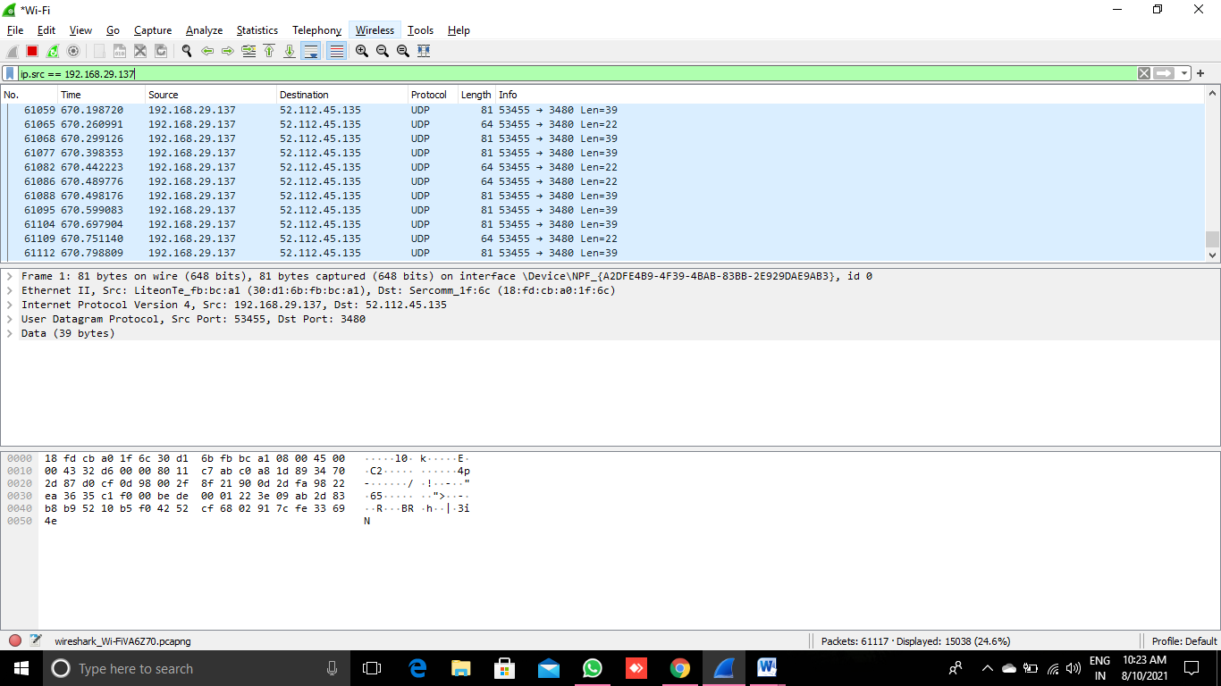

ip.dst == 192.168.29.137

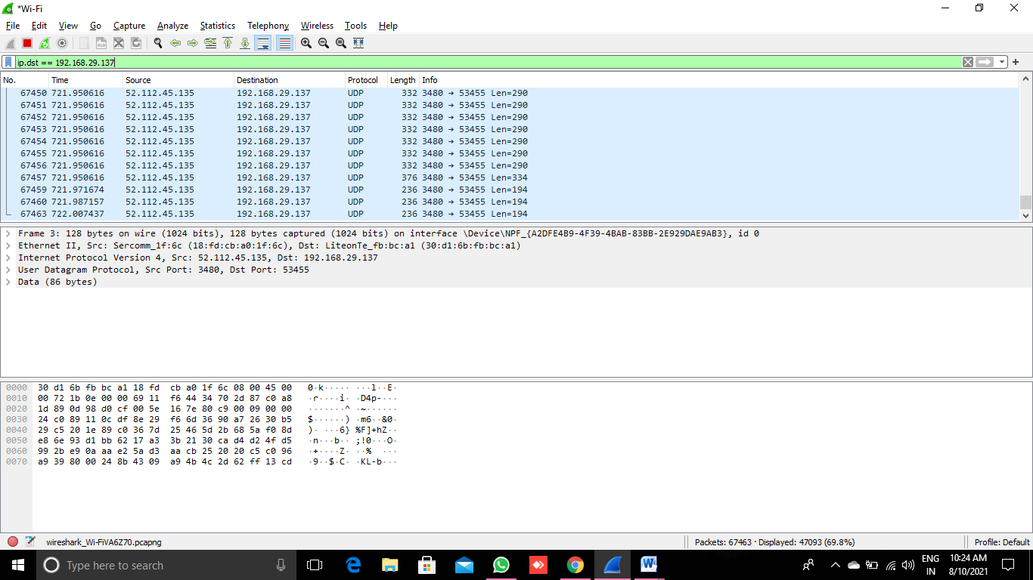

http||arp

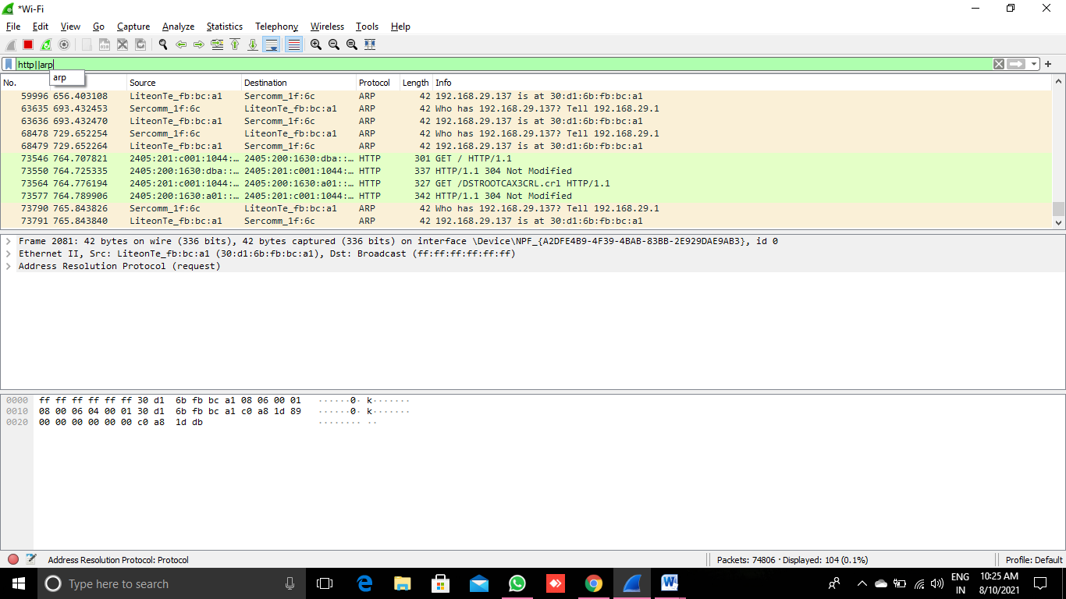

udp && ip.src==10.31.32.108

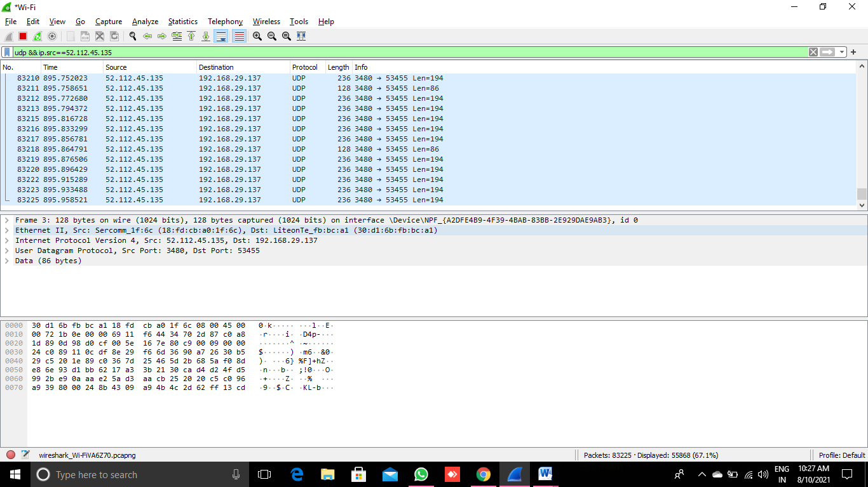

udp.port eq 50006

**ip.addr == 192.168.29.137**

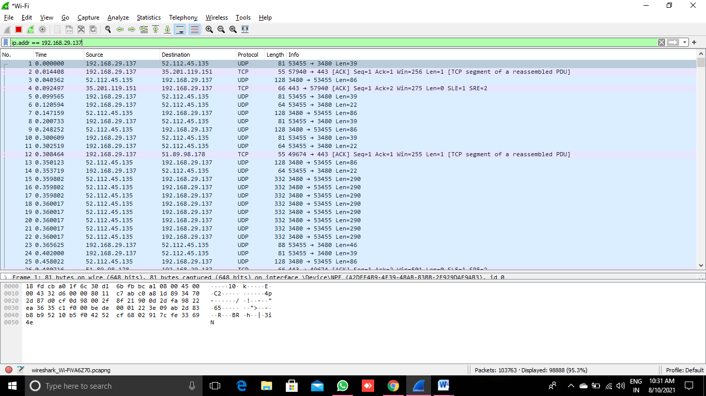

http.response.code==200

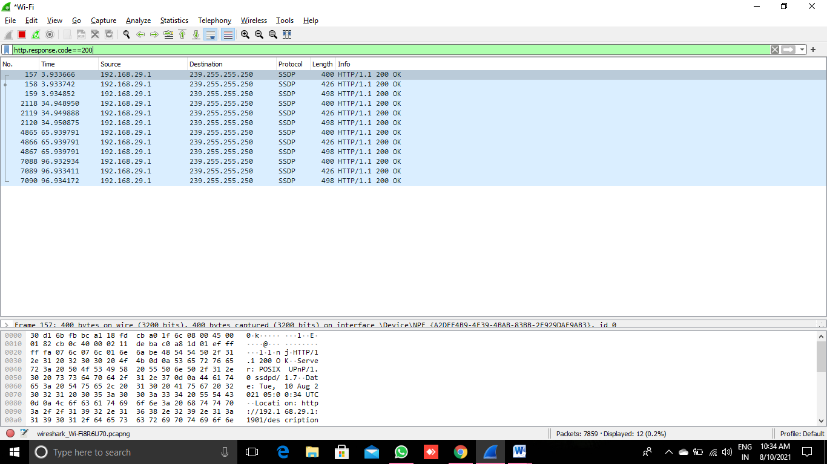

All Ipi address 52.112.45.135: 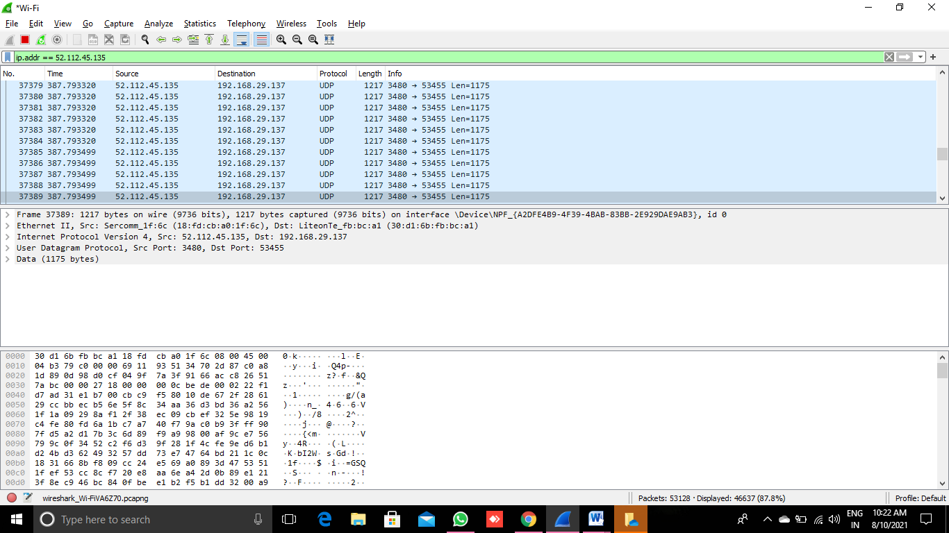

LAB 2:

nmap 127.0.0.1

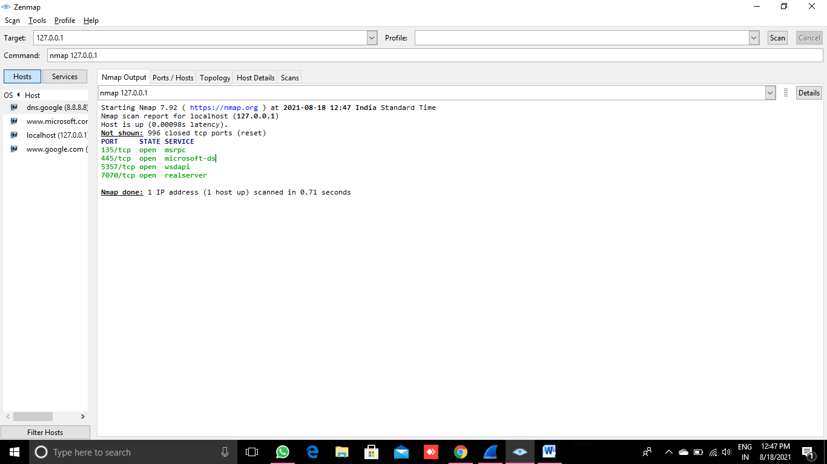

nmap [www.google.com](https://www.google.com)

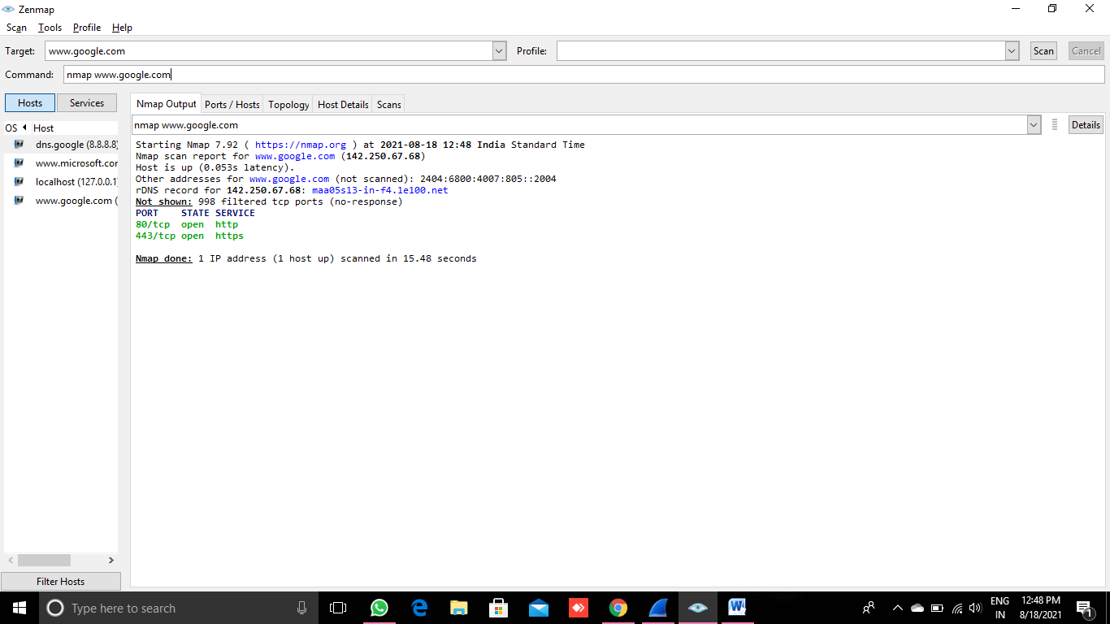

nmap **8.8.8.8**

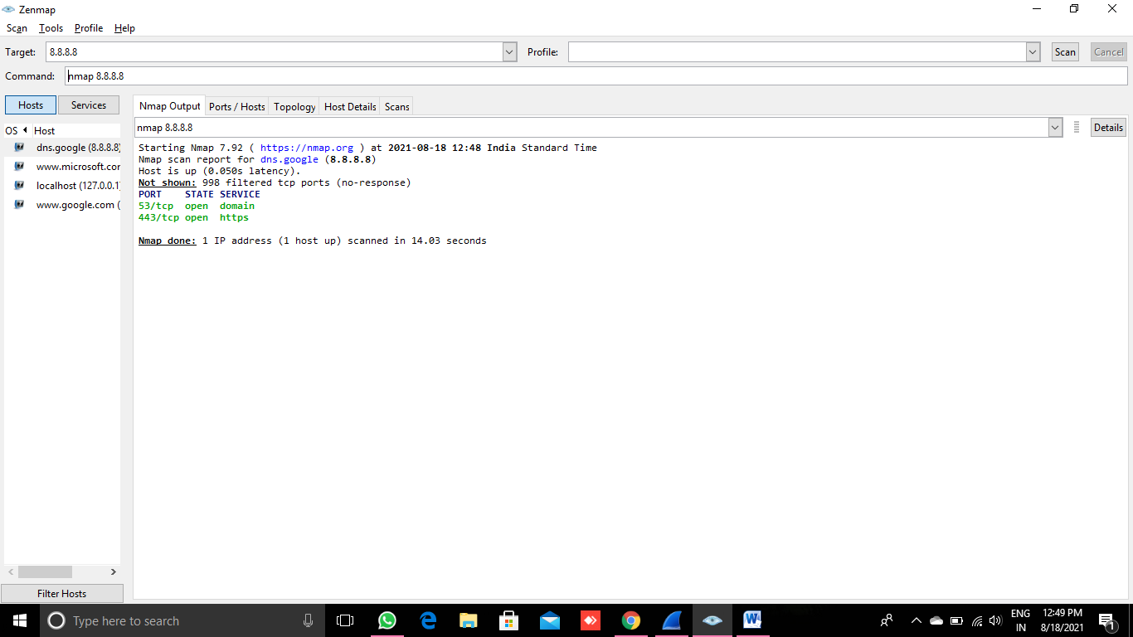

nmap 8.8.8.1-10

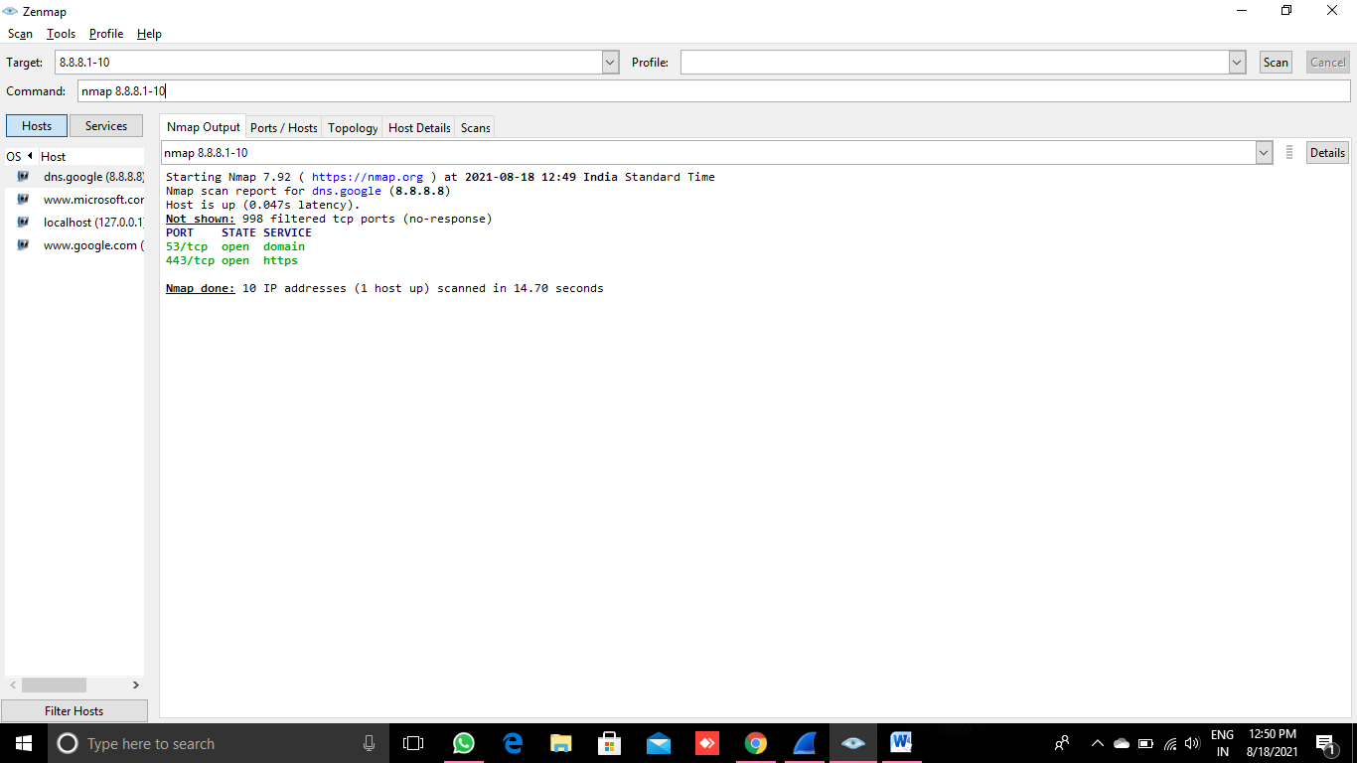

nmap 8.8.8.11/24

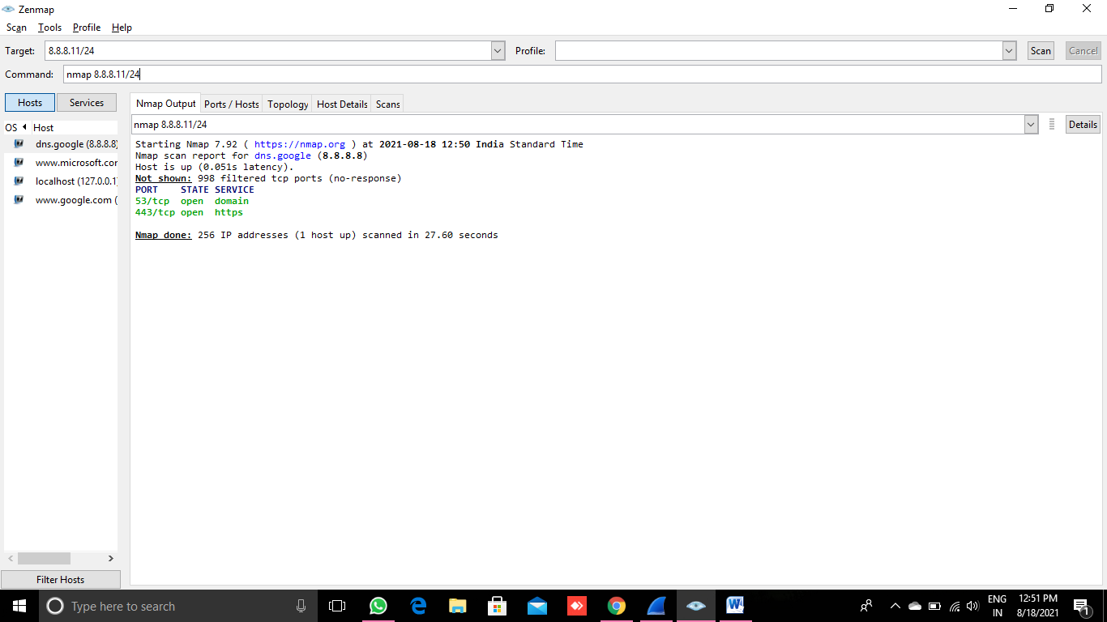

nmap -p 443 8.8.8.8

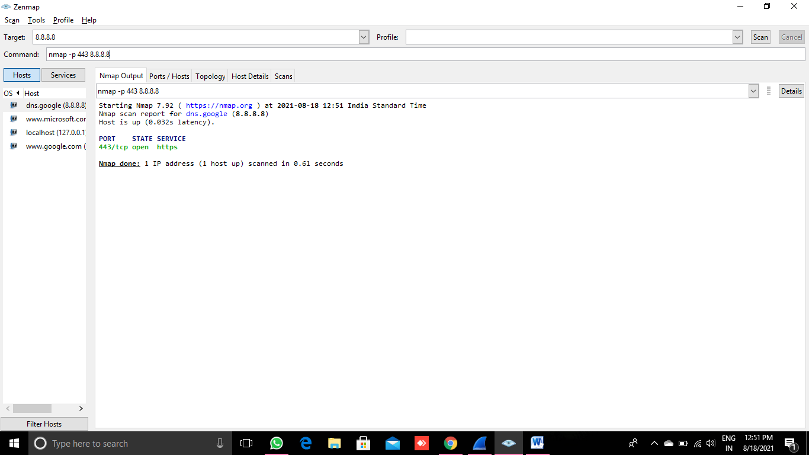

nmap -p 1-1024 8.8.8.8

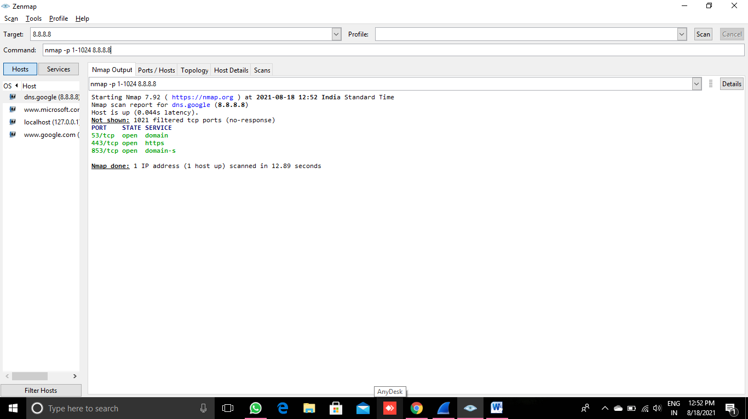

nmap -Pn 8.8.8.8

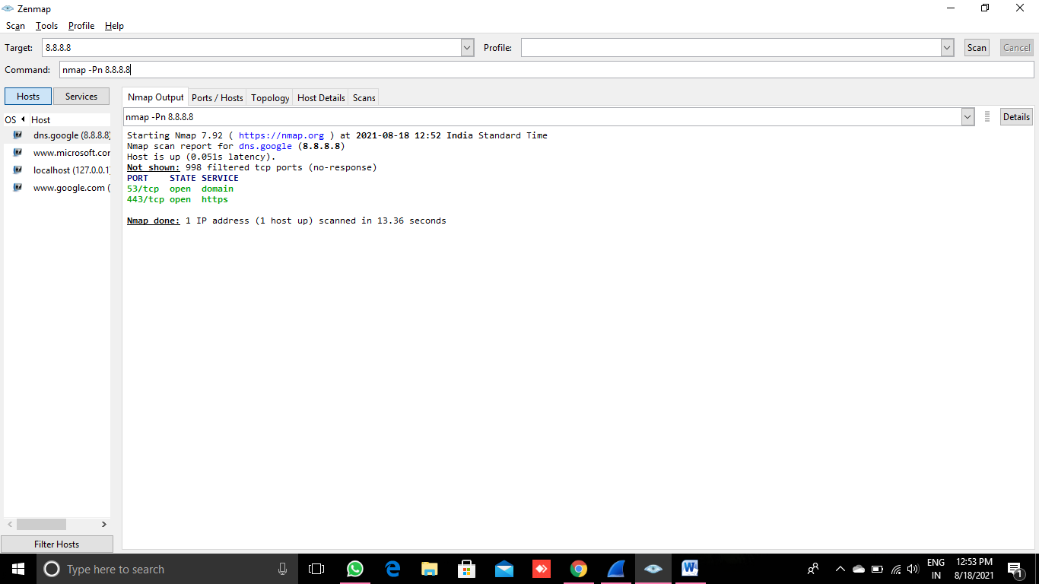

nmap -sT [www.microsoft.com](http://www.microsoft.com)

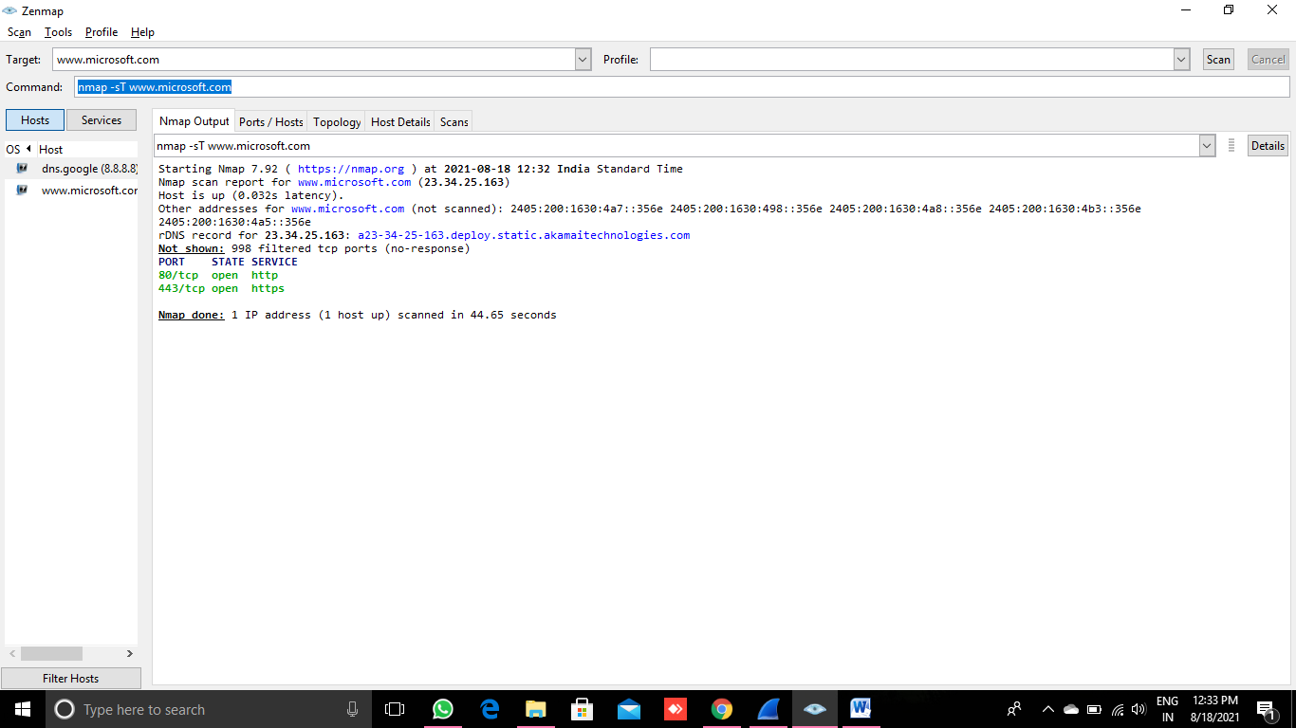

nmap -sS [www.microsoft.com](http://www.microsoft.com)

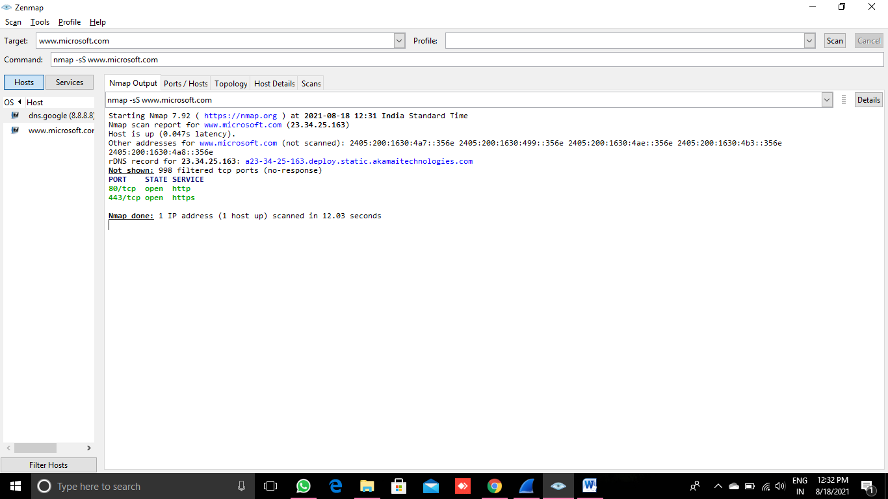

nmap -sU [www.google.com](https://www.google.com)

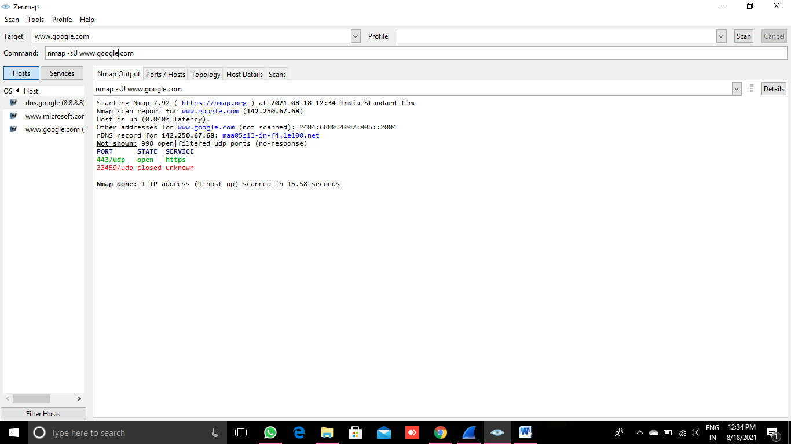

nmap -sU [www.microsoft.com](http://www.microsoft.com)

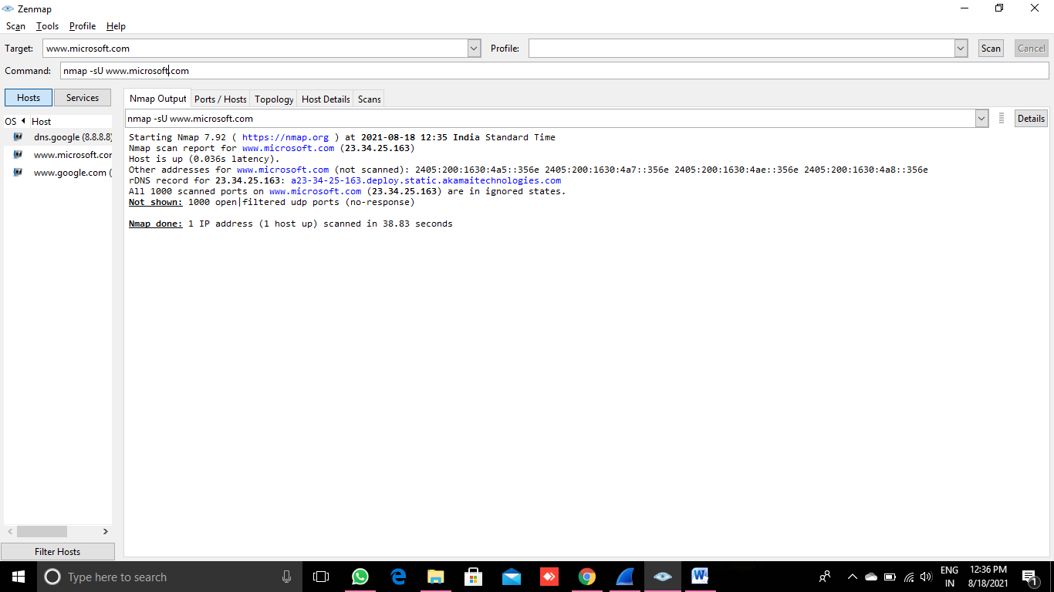

nmap -sA [www.google.com](http://www.google.com)

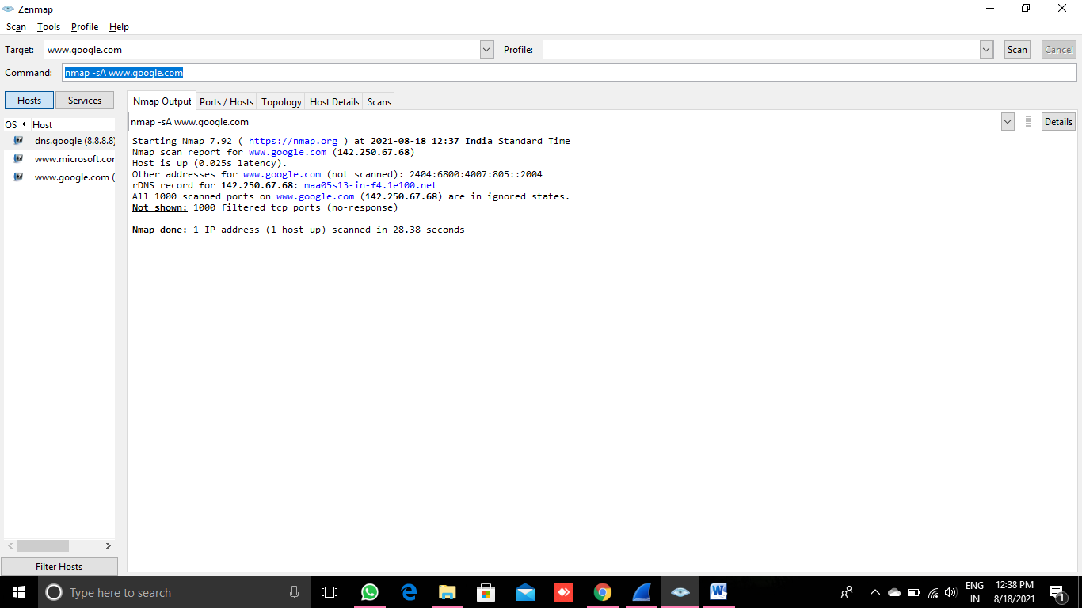

nmap -sN [www.google.com](https://www.google.com)

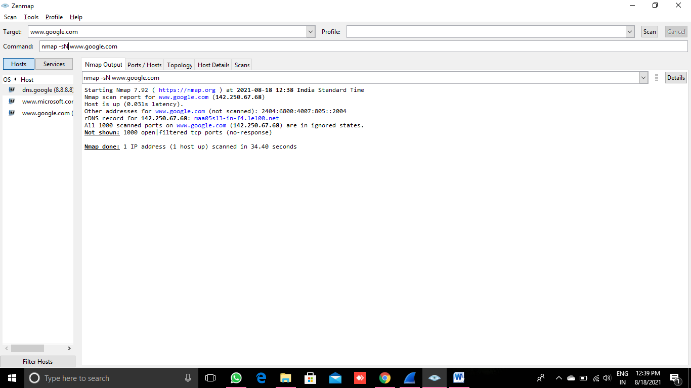

nmap -sF [www.google.com](https://www.google.com)

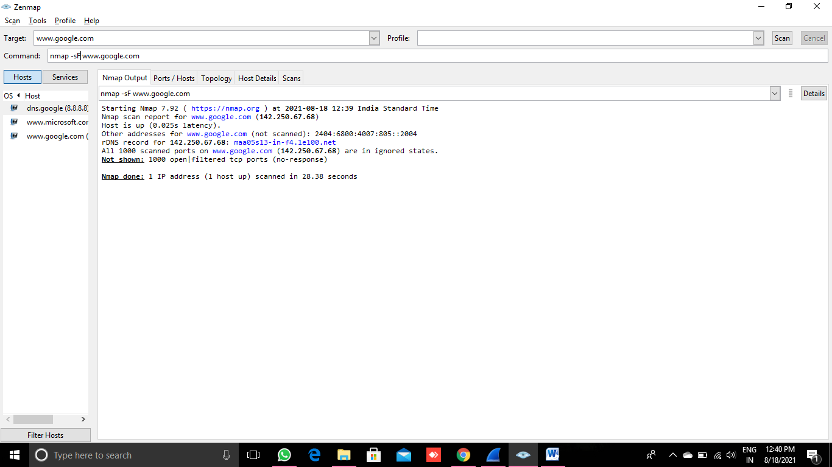

nmap -sX [www.google.com](https://www.google.com)

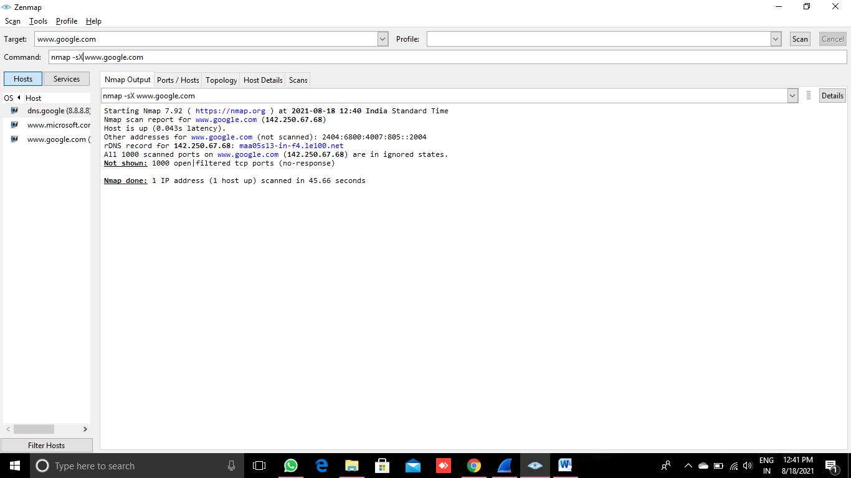

nmap -A [www.google.com](http://www.google.com)

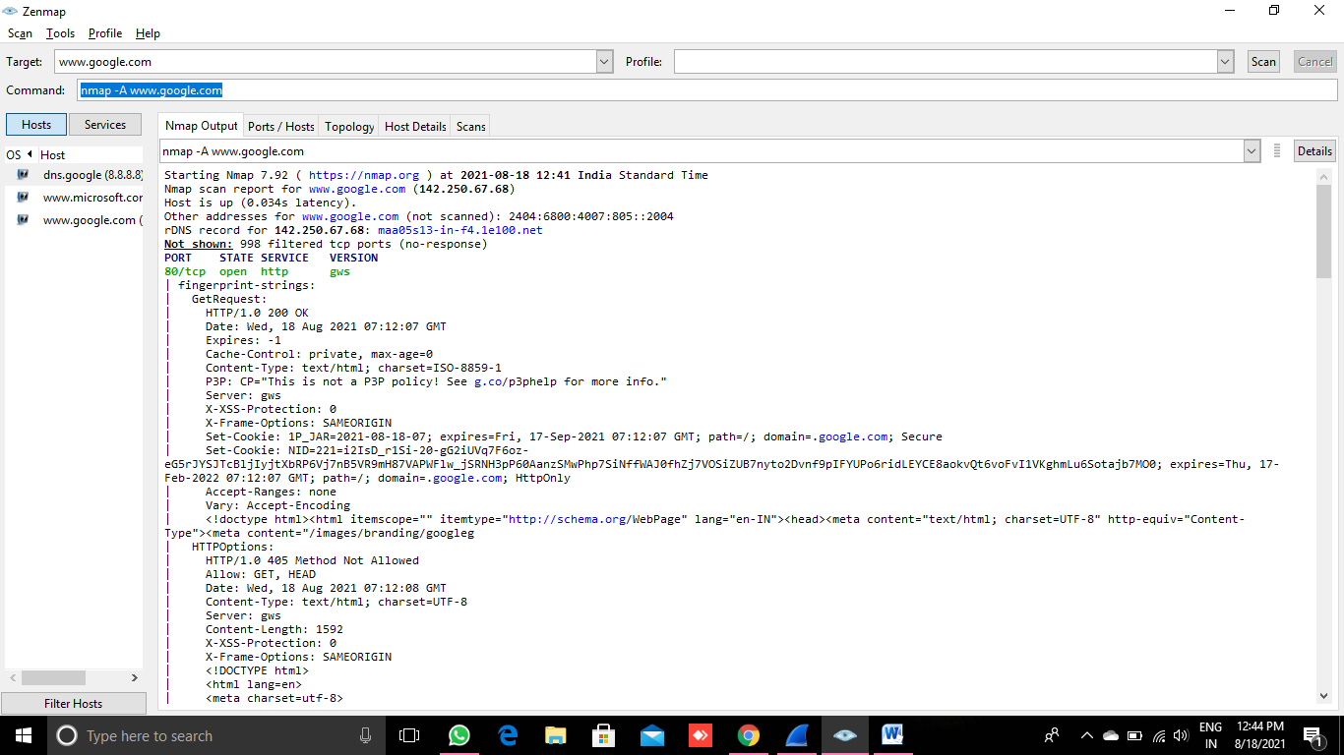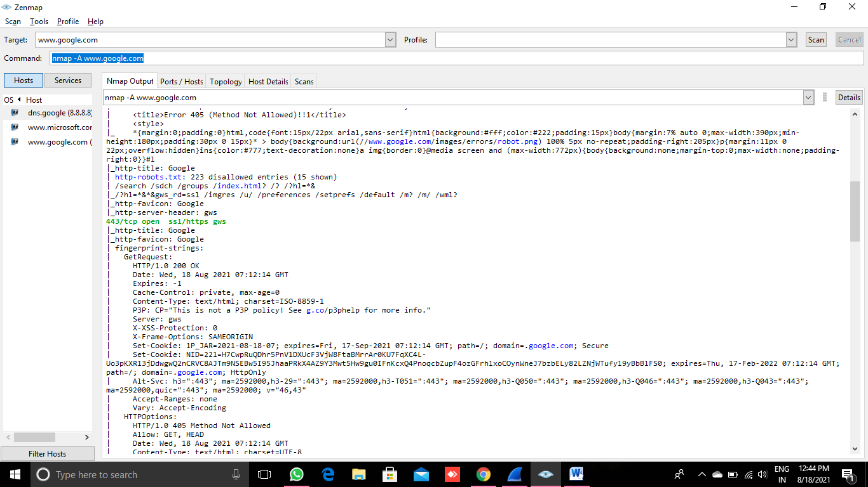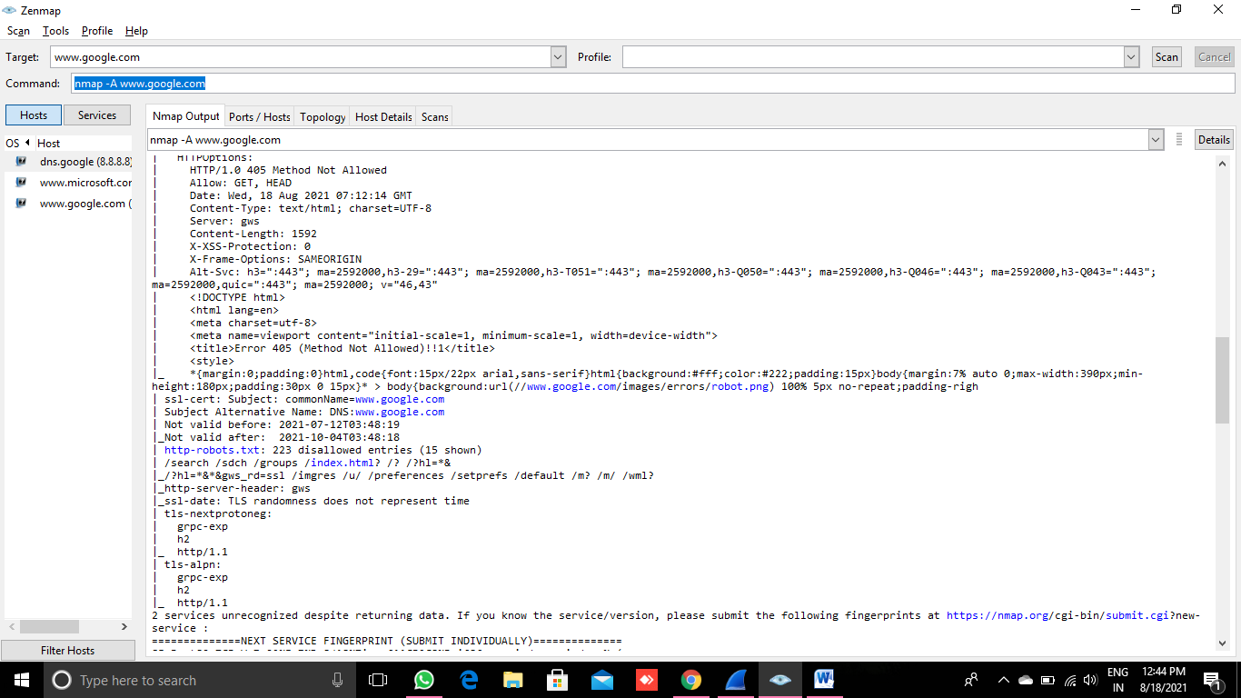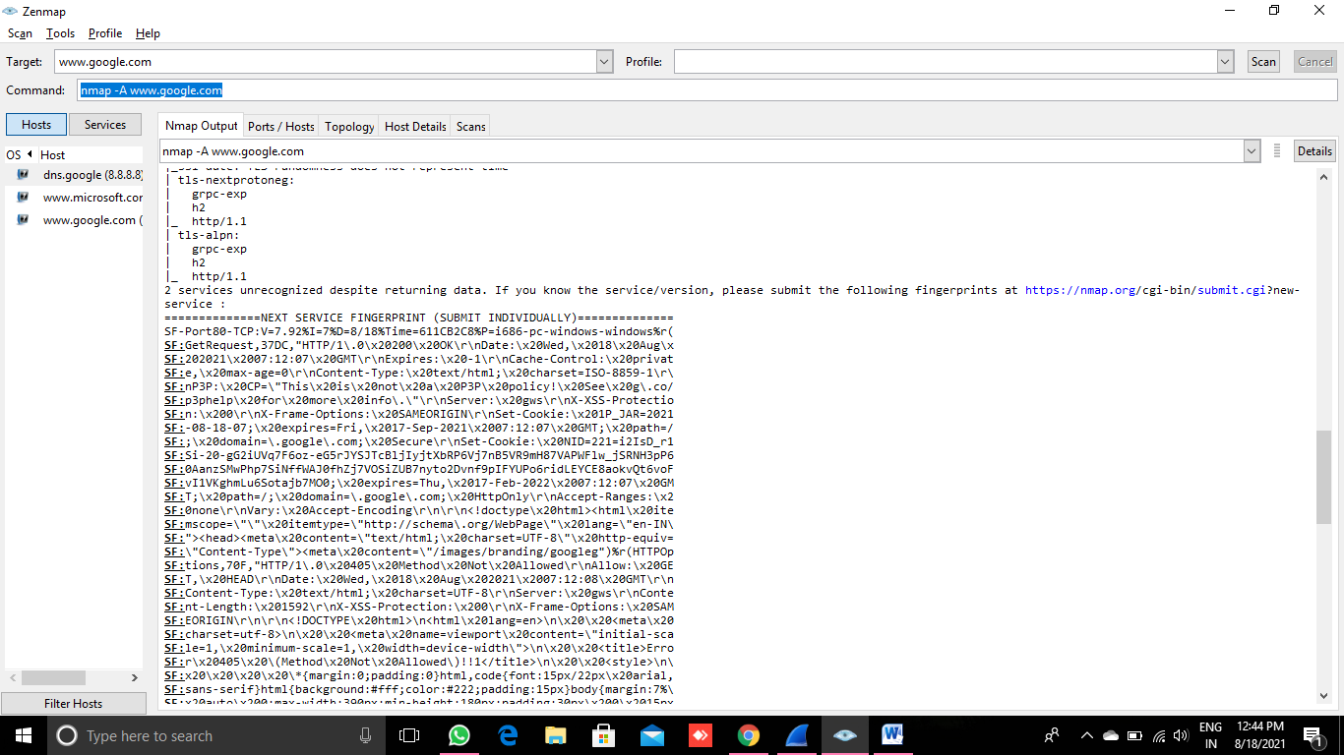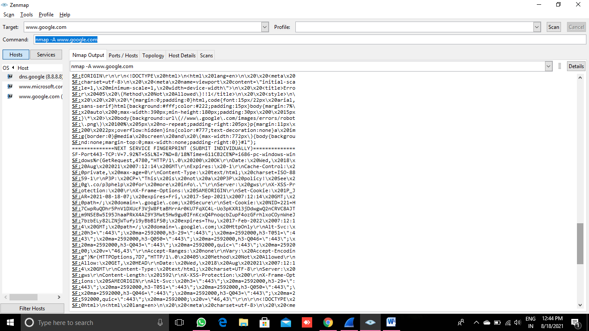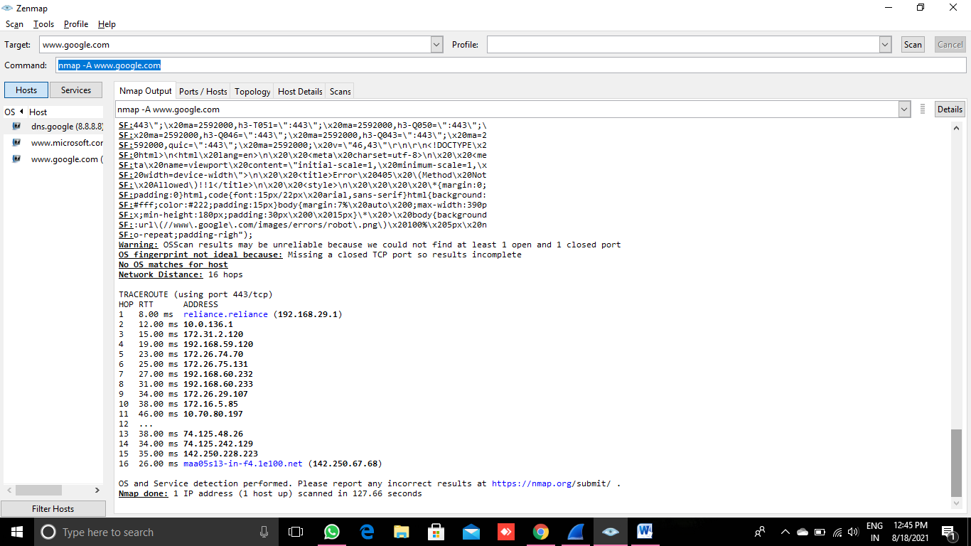

nmap –sV [www.google.com](http://www.google.com)

